[Insert your company logo]

For Immediate Release – [Put release date here]

Media Contact:
[Name and title of person the press should contact]
[Office telephone and/or cell number]
[Email address]

[TITLE OF YOUR RELEASE – For Example: JAG WINDOW TINTING & TREATMENTS NAMED 3M NATIONAL NEW DEALER OF THE YEAR)]

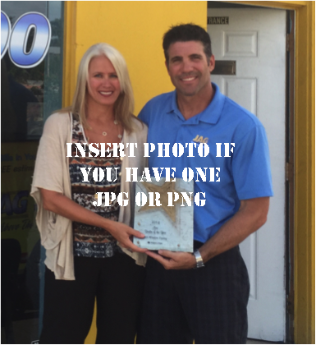
(Your City, ST) – [Insert copy about your award or recognition in the first paragraph. For example, JAG Window Tinting & Treatments has been named 3M’s National New Dealer of the Year for residential, commercial and automotive window film products. The company, which is headquartered in Cocoa and has additional offices in Orlando and Indianapolis, IN, beat out more than 200 3M Authorized Prestige Dealers from across the United States to earn the prestigious award.]

[Insert a quote from your company owner or president in paragraph 2. For example, “We are honored to be recognized by 3M as a national leader in sales and customer service for superior quality window film products,” said JAG president James Gadient, who along with his wife, Michelle, own and operate the company.

[Insert information about your company history and areas of special expertise in paragraph 3. Often, you can use information from the About Us section of your website for this. For example, Although originally established in 1993, JAG became an exclusive 3M Authorized Prestige Window Film Dealer in fall 2013 and handles the company’s full line of sun control and energy saving films, safety and security films and decorative films for residential and commercial purposes. They also specialize in 3M’s sun control, safety & security, and paint protection films for automotive and marine uses.]

[Optional - Use paragraph 4 for any additional information you want to include about your company and/or your products.]

[End your release with contact information for your company, including your web address and phone number so that editors and readers know how to learn more about your company.]

###

