[Insert your company logo]

For Immediate Release – [Put release date here]

Media Contact:
[Name and title of person the press should contact]
[Office telephone and/or cell number]
[Email address]

[Place Title of Your Release Here - For Example, ABC Window Tinting Completes Installation for Marriott City Center Hotel]

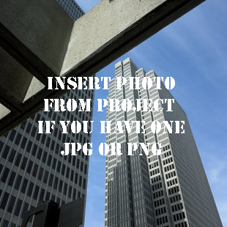
(Your City, ST) – [Paragraph 1: Insert copy about the completed project in paragraph 1. Make sure you mention why it is important or relevant. For example, ABC Window Tinting of Atlanta recently completed installation of solar and security window film for the Marriott City Center Hotel. The project, which included more than 100,000 square feet of 3M Ultra Night Vision window film, is expected to reduce the landmark hotel’s energy costs by 20% annually while providing enhanced storm and security protection.]

[Optional: Insert a quote from your company owner or president in this paragraph. For example, you might include a comment about a special feature related to the project or a statement about how honored you are that your company was chosen for the project. Don’t fret. The quote doesn’t have to be anything long or involved, just something that adds a personal touch to the release.]

[This paragraph is a good place to put information about your company that will catch the attention of editors and potential customers. For example, are you an expert in certain types of installations or have you completed other high-profile projects that are worth mentioning? Or maybe you want to mention something about your company’s history and various awards you have received? Be creative. This is a paragraph designed to make people want to learn more.]

[End your release with contact information for your company, including your web address and phone number so that editors and readers know how to learn more about your company.]

###

